TRANSFER OF MORE THAN ONE EMBRYO INFORMED CONSENT FORM
JAYA SUPER-SPECIALTY FERTILITY CENTRE &
CENTRE FOR REPRODUCTIVE GENETICS AND IMMUNOLOGY

As a patient, you have the right to receive complete and accurate information about your treatment options and the potential risks and benefits associated with them. This informed consent document is intended to provide you with the necessary information to make an informed decision about transferring more than one embryo at a time. Prospective parents should be aware that transferring more than one embryo increases the likelihood of multiple pregnancies, which carry higher risks for both the mother and the child.
- What are the outcomes in the mother?
Transferring more than one embryo is associated with a higher risk of multiple pregnancy and of being admitted to hospital before labour, of miscarriage, ectopic pregnancy, gestational diabetes, pre-eclampsia, bleeding before, during and after labour, preterm labour, operative delivery. Mothers of twins experience post-partum depression more often.
- What are the outcomes in child?
Multiple pregnancies increase the risk of fetal and neonatal complications such as congenital anomaly, prematurity, low birth weight, admission to neonatal intensive care unit, and stillbirth. Prematurely born children often require frequent outpatient and hospital health visits because they have various medical problems during childhood.
- What are other outcomes related to multiple pregnancies?
Multiple pregnancies and being parent of twins/multiples are associated with increased overall costs due to sick leave days, medication, days off also taken when caring for an ill child. Caring for twins is marked by higher levels of stress, which can affect the relationship of the parents.
- What are my alternatives?
You have the option to have the transfer of a single embryo. This reduces the above-mentioned risks of multiple pregnancies without decreasing your chances of a successful pregnancy. Additional embryos can be cryopreserved and used later. This allows for more control over the timing and number of pregnancies. However, success rate per cycle is/may be lower than in multiple embryos transfer.
One more option is to know the ploidy status of the embryo and transferring Euploid embryo for shorter time to pregnancy.
There is another option of fetal reduction usually done in first trimester of in case of confirmed multi fetal gestation. This is a method of reducing the number of fetus(es) by one or more. It carries a 7-10% risk of miscarriage depending on the method chosen.
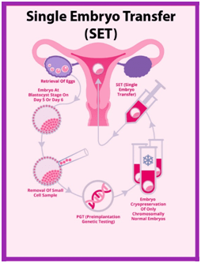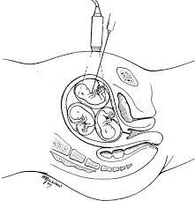
I/We, the prospective parents, hereby confirm that we have received adequate counselling regarding the risks associated with the transfer of more than one embryo.
I/We, the prospective parents, hereby confirm that we have received adequate counselling regarding the risks associated with the transfer of more than one embryo.
I/We also confirm that I/we
- Have received detailed information document on IVF/ICSI techniques themselves, on the benefits, disadvantages and risks associated with IVF/ICSI treatment
- Have been informed on different transfer options, including (elective) single embryo transfer and fetal reduction subsequently
- Have accepted the risks and complications that might occur during and after treatment when transferring more than one embryo.
I have read and understand the information provided above regarding the risks associated with transferring more than one embryo at a time, including the risks of multiple pregnancies for both the mother and the child. I understand that there are alternatives to transferring more than one embryo and that I have the right to make an informed decision about my treatment options. I acknowledge that my healthcare provider has explained the potential risks and benefits of transferring ___________________ embryos and has answered all of my questions to my satisfaction.

Male Partner:
NAME | ADDRESS | SIGNATURE WITH DATE

Female Partner:
NAME | ADDRESS | SIGNATURE WITH DATE

Name, address & signature of the Witness from the clinic:
NAME | ADDRESS | SIGNATURE WITH DATE

Name and signature of the Doctor
NAME: | SIGNATURE WITH DATE:
Name and address of the ART clinic:

